**LOOPS**

**For Loop**

A for loop is used for iterating over a sequence (that is either a list, a tuple, a dictionary, a set, or a string).

**for val in sequence:**

**loop body**

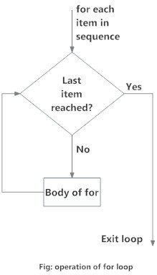

**break Statement**

With the break statement we can stop the loop before it has looped through all the items.

for i in RYB_color:

if(i == "Yellow"):

break

print(i)

>>> Red

**continue Statement**

With the continue statement we can stop the current iteration of the loop, and continue with the next.

for i in RYB_color:

if(i == "Yellow"):

continue

print(i)

>>> Red

>>> Blue

**The range() Function**

The range(n) is a function that returns a sequence of numbers, starting from 0 by default, and increments by 1 (by default), and ends at (n -1).

for i in range(3):

print(i)

>>> 0

>>> 1

>>> 2

**Else in For Loop**

for i in range(3):

print(i)

else:

print("finally finished !")

>>> 0

>>> 1

>>> 2

>>> finally finished !

**Nested Loops**

list_1 = ["Data" , "‐ Machine learning"]

list_2 = ["Scientis‐ t","Engineer"]

for i in list_1:

for j in list_2:

print(i,j)

>>> Data Scientist

>>> Data Engineer

>>> Machine Learning Scientist

>>> Machine Learning Engineer

**pass Statement**

for loops cannot be empty, but if we for some reason have a for loop with no content, we can put in the pass statement to avoid getting an error

for i in RYB_color:

pass

**While Loop**

With the while loop we can execute a set of statements as long as a condition is true.

**while test_expression:**

**Body of while**

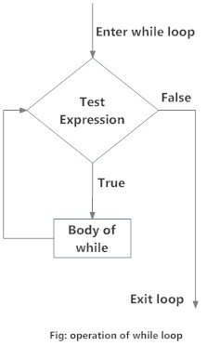

**break Statement**

### With the break statement we can stop the loop even if the while condition is true.

### i = 1 while i < 4:  ­ ­ ­  print(i)  ­ ­ ­  if (i == 2):         break  ­ ­ ­  i += 1 >>> 1

**continue Statement**

### With the continue statement we can stop the current iteration, and continue with the next.

### i = 1 while i < 4:  ­ ­ ­  print(i)  ­ ­ ­  if (i == 2):         continue  ­ ­ ­  i += 1 >>> 1 >>> 3

### The else Statement

### i = 1 while i < 4:  ­ ­ ­  print(i)  ­ ­ ­  i += 1 else:  ­ ­ ­  print(­"i is no longer less than 4") >>> 1 >>> 2